

**CSC 1103:**

**Object Oriented Programming**

**Group Project**

**Project title: Restaurant Billing System**

**(Fast Food Restaurant)**

Submitted To: **Ali A.Alwan**

Group Members:

1. Md Afique Amin Zian (1631005)
2. Nasik Sami Khan(1638153)
3. Mehran Mujib(1632625)
4. Abu Sayed Mohammed Saad(1634677)

**Summary:**

The name of our project is Restaurant Billing System (Fast Food Restaurant). The task of this system is taking the order of the customer and show them the price then take the price by using either cash or master card, debit card or visa card. There is a lot of various dishes started from meal and vegetarian, desserts, sandwich, shakes and drinks. We have varieties of food in each category.

Whenever, customer ask for food. First he need to order. The person who will take the order first need to select the Combo Box of the item then give input of the quantity. After finishing to take order, the customer need to pay based on the output which will be shown in the screen. If customer want to pay with cash then first he need to give money and after that he will get the change.

**Benefits:**

1. Easy to handle.
2. Don’t need any other tool except Java to run this system.
3. Receptionist can easily compute the
4. Customer will not need to wait for a long to get order and finish payment process.
5. Its time reducing system.

**User:**

1. Receptionist of the store

**Introduction:**

When we are planning to choose topics for our project the things that we give priority is that the system must be user friendly and easy to use and customer can get benefits from this system. We choose this system (Restaurant Billing System) .

Our system is mainly **Fast Food Restaurant System.**

**There are three main advantages to fast food.**

* You can save money because fast food tends to be cheaper than the alternatives.
* You can save time as there is very low or no waiting time for food to be served.
* There are many healthy fast food options now so no need to eat fat-filled burgers and fries.

In our project we are planning to go with the reception computer to calculate the total expenditure by a customer and take the money.

We used java.swing and netbeans to draw our interface , In our interface we have designed some combo box , label box, option buttons and text fields. Then we have done our coding part based on the particular boxes. There are three button which are the total button , Reset button and exit button. If you pressed the total button , the total money will pop up in the screen.

First you need to give correct mark to the combo box which items you want to purchase . Later the text field will be ready to key in the quantity . You might key in any numeric number that will be the quantity. And based on that the total items and there price will be calculated. And will show in the text field.

The customer can pay the bill by using their credit card or debit card, master card or by using hard cash. If the customer want to pay by using hard cash the change will be automatically shown in the text box.

In our project we have created several class function, and try to use them in the coding part.

The classes are fast food, meat, drinks , desserts, and shakes . There are several combo box for the menu card like fries, salad, chocolate milk shake, vanilla cone, vanilla milk shake and so on.

There is a text box field for the change , total , subtotal and tax menu.

**Lessons learned from the project:**

1. How to create interface using java.
2. How to do the coding part.
3. How can you use the fast food restaurant billing system.
4. We face some troubles regarding the project and we take help from youtube and google. So this will help us to increase our knowledege.
5. We can implement this in further processes like making other system easily, or improve this system take it to the another level. Make it more complex and user friendly.

**The UML Class Diagram:**

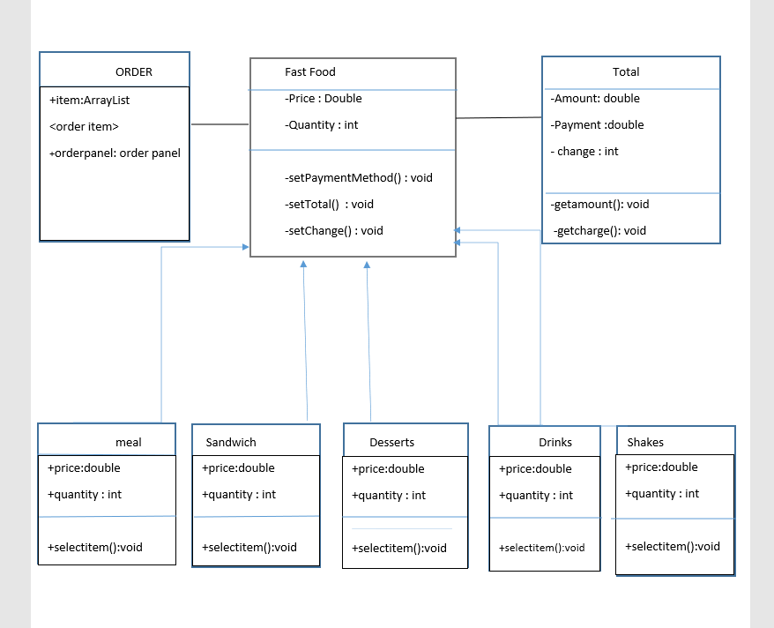

**The task distribution:**

|  |  |
| --- | --- |
| **Task** | **Member Name** |
| 1. **Design of interface**   -checkbox  -combobox  -text field  -button | Every one |
| 1. **UML Class Diagram** | Nasik Sami Khan |
| 1. **Coding of reset button , total button**   -active it  -run code  -mouse clicked action performed  -calculating | Md. Afique Amin Zian |
| 1. **Subtotal , Change and Tax option**   -active it  -run code  -mouse clicked action performed  -calculating | Mehran Mujib |
| 1. Inheritance | Abu Sayed Mohammed saad |
| 1. Overloading | MD. afique Amin Zian |
| 1. Overridng | Mehran Mujib |
| 1. Enable Combo Box | Nasik Sami Khan |
| 1. Array | Abu Sayed Mohammed Saad |
|  |  |

**Snapshot Of interface design:**

**First Interface**

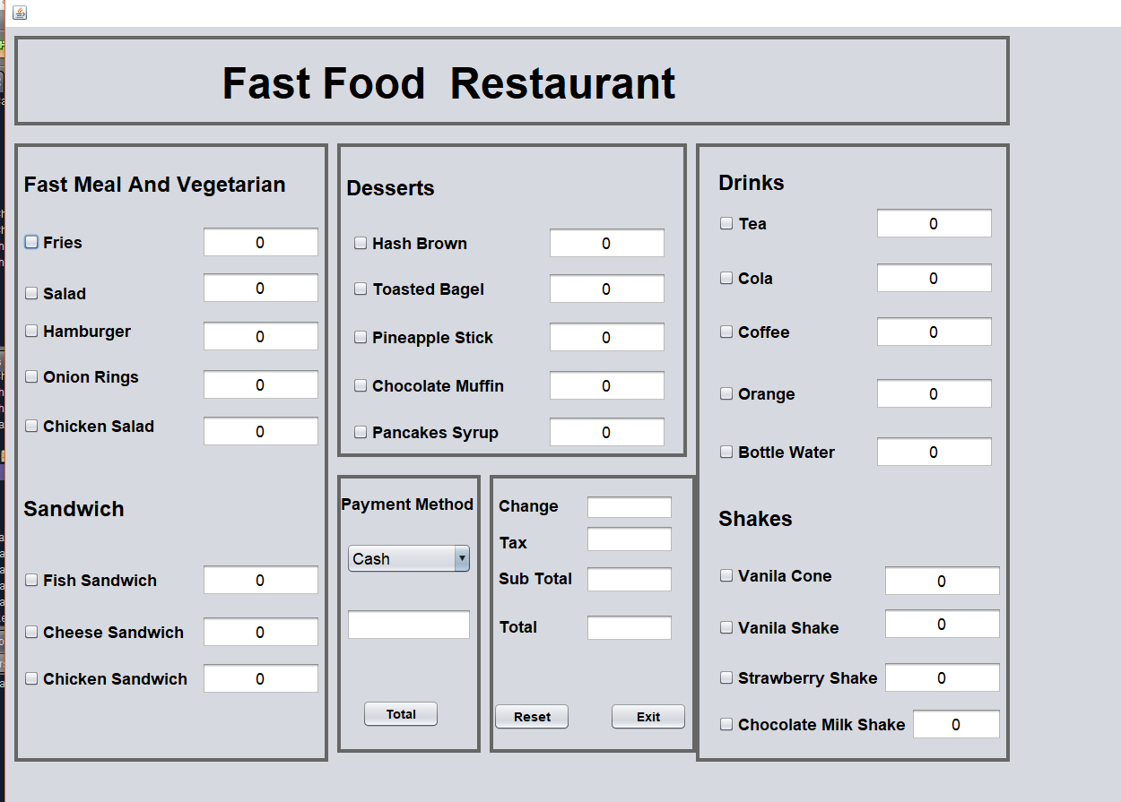

**After Calculating the interface will look like this**

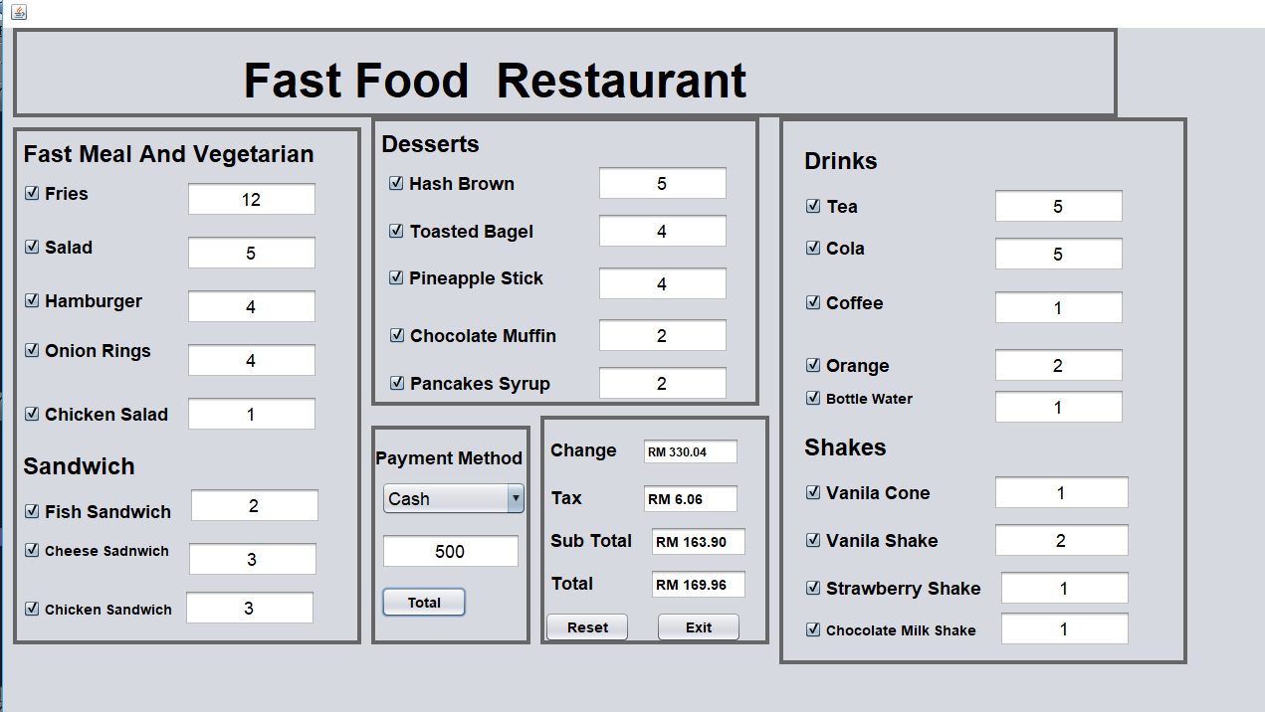

**Design of the interface:**

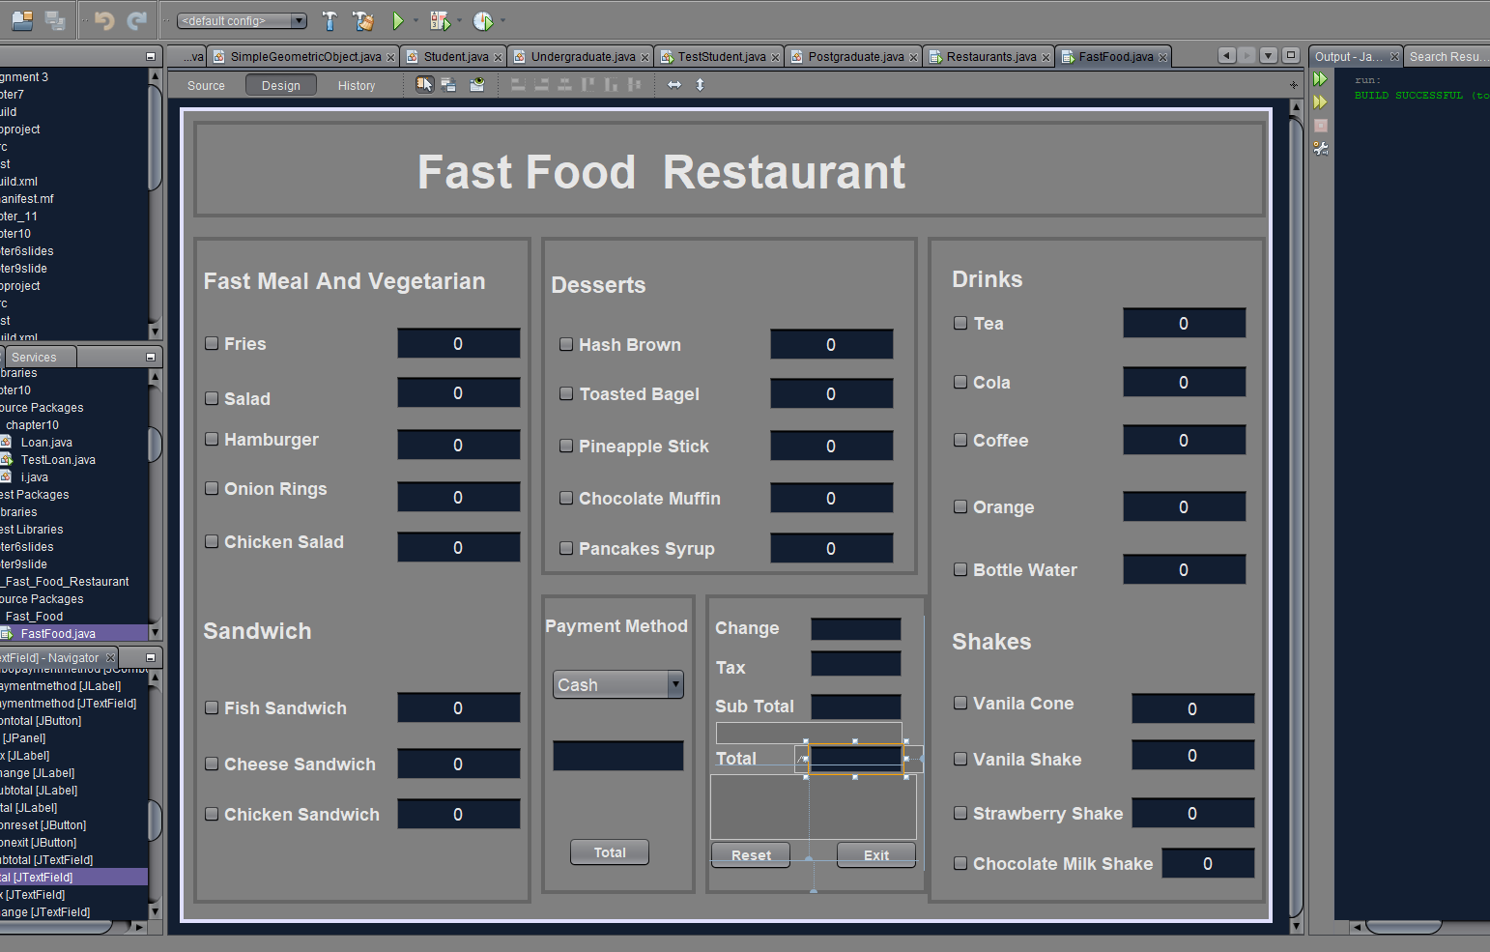

**List of challenges Faced.**

1. Regarding the design we don’t actually know how to use several boxes. So we take help from google and youtube and also the slides.
2. To compare with the UML class and Inheritence part we faced problem to run our code
3. To calculate overall total and subtract it from cash, we don’t know the method which have to use.
4. To create the exit button we take help from google to write down the code.
5. To clear all of the text field after clicking the Reset button , For this thing we take help from Youtube to see how the codes work.
6. While run the project the total button is not working properly, so we take time to find the problem.

**References and got help from:**

1.slides

2.youtube

3. google

…….END……